



**Intellectual Property Management Plan**

**February 28, 2011**

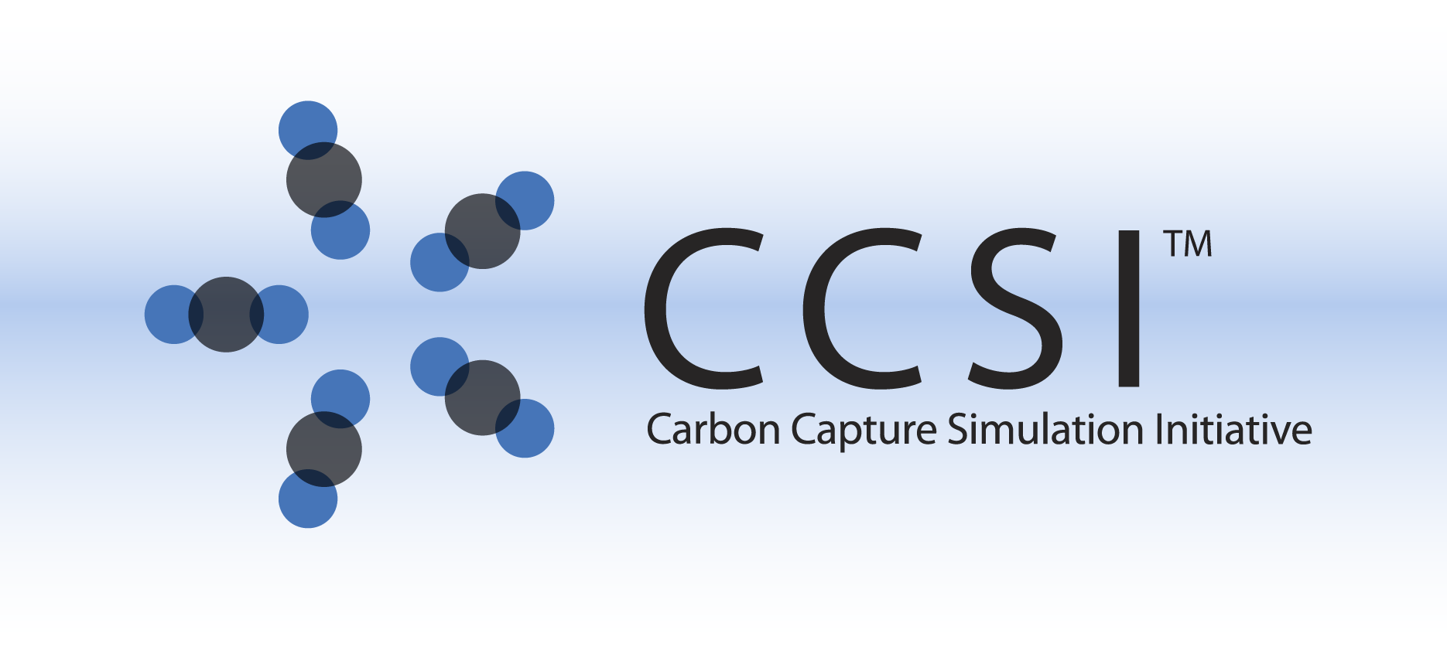

iRevealLite INSTALLATION GUIDE

Version 2.0.0

February 2018

Copyright (c) 2012 - 2018

**Copyright Notice**

iRevealLite was produced under the DOE Carbon Capture Simulation Initiative (CCSI), and is copyright (c) 2012 - 2018 by the software owners: Oak Ridge Institute for Science and Education (ORISE), Los Alamos National Security, LLC., Lawrence Livermore National Security, LLC., The Regents of the University of California, through Lawrence Berkeley National Laboratory, Battelle Memorial Institute, Pacific Northwest Division through Pacific Northwest National Laboratory, Carnegie Mellon University, West Virginia University, Boston University, the Trustees of Princeton University, The University of Texas at Austin, URS Energy & Construction, Inc., et al.. All rights reserved.

NOTICE. This Software was developed under funding from the U.S. Department of Energy and the U.S. Government consequently retains certain rights. As such, the U.S. Government has been granted for itself and others acting on its behalf a paid-up, nonexclusive, irrevocable, worldwide license in the Software to reproduce, distribute copies to the public, prepare derivative works, and perform publicly and display publicly, and to permit other to do so.

**License Agreement**

iRevealLite Copyright (c) 2012 - 2018, by the software owners: Oak Ridge Institute for Science and Education (ORISE), Los Alamos National Security, LLC., Lawrence Livermore National Security, LLC., The Regents of the University of California, through Lawrence Berkeley National Laboratory, Battelle Memorial Institute, Pacific Northwest Division through Pacific Northwest National Laboratory, Carnegie Mellon University, West Virginia University, Boston University, the Trustees of Princeton University, The University of Texas at Austin, URS Energy & Construction, Inc., et al. All rights reserved.

Redistribution and use in source and binary forms, with or without modification, are permitted provided that the following conditions are met:

1. Redistributions of source code must retain the above copyright notice, this list of conditions and the following disclaimer.
2. Redistributions in binary form must reproduce the above copyright notice, this list of conditions and the following disclaimer in the documentation and/or other materials provided with the distribution.
3. Neither the name of the Carbon Capture Simulation Initiative, U.S. Dept. of Energy, the National Energy Technology Laboratory, Oak Ridge Institute for Science and Education (ORISE), Los Alamos National Security, LLC., Lawrence Livermore National Security, LLC., the University of California, Lawrence Berkeley National Laboratory, Battelle Memorial Institute, Pacific Northwest National Laboratory, Carnegie Mellon University, West Virginia University, Boston University, the Trustees of Princeton University, the University of Texas at Austin, URS Energy & Construction, Inc., nor the names of its contributors may be used to endorse or promote products derived from this software without specific prior written permission.

THIS SOFTWARE IS PROVIDED BY THE COPYRIGHT HOLDERS AND CONTRIBUTORS "AS IS" AND ANY EXPRESS OR IMPLIED WARRANTIES, INCLUDING, BUT NOT LIMITED TO, THE IMPLIED WARRANTIES OF MERCHANTABILITY AND FITNESS FOR A PARTICULAR PURPOSE ARE DISCLAIMED. IN NO EVENT SHALL THE COPYRIGHT OWNER OR CONTRIBUTORS BE LIABLE FOR ANY DIRECT, INDIRECT, INCIDENTAL, SPECIAL, EXEMPLARY, OR CONSEQUENTIAL DAMAGES (INCLUDING, BUT NOT LIMITED TO, PROCUREMENT OF SUBSTITUTE GOODS OR SERVICES; LOSS OF USE, DATA, OR PROFITS; OR BUSINESS INTERRUPTION) HOWEVER CAUSED AND ON ANY THEORY OF LIABILITY, WHETHER IN CONTRACT, STRICT LIABILITY, OR TORT (INCLUDING NEGLIGENCE OR OTHERWISE) ARISING IN ANY WAY OUT OF THE USE OF THIS SOFTWARE, EVEN IF ADVISED OF THE POSSIBILITY OF SUCH DAMAGE.

You are under no obligation whatsoever to provide any bug fixes, patches, or upgrades to the features, functionality or performance of the source code ("Enhancements") to anyone; however, if you choose to make your Enhancements available either publicly, or directly to Lawrence Berkeley National Laboratory, without imposing a separate written license agreement for such Enhancements, then you hereby grant the following license: a non-exclusive, royalty-free perpetual license to install, use, modify, prepare derivative works, incorporate into other computer software, distribute, and sublicense such enhancements or derivative works thereof, in binary and source code form. This material was produced under the DOE Carbon Capture Simulation Initiative

Table of Contents

1. Introduction 1

2. Prerequisites 1

2.1. Hardware 1

2.2. Software 1

2.2.1 Required third party software packages for end users 1

2.2.2 Required third party software packages for developers 1

2.2.3 Software packages for integrating ROM with process system engineering package 1

3. Basic Installation 2

3.1. Third Party Software Installation 2

3.1.1 Java installation 2

3.1.2 Aspen Installation 2

Follow AspenTech’s installation guide to install ACM and Aspen Plus version 9 or higher. 2

3.2. Product Build 2

3.3. Product Installation 3

3.3.1 Install iRevealLite Manually 3

3.3.2 Install iRevealLite Through MSI Installer on Windows 3

4. Installation Test 3

5. Installation Problems 4

5.1. Known Issues/Fixes 4

5.2. Reporting Installation issues 4

# Introduction

iRevealLite framework is a toolkit for generating reduced order models (ROMs) from high-fidelity model simulations. It has been developed under Carbon Capture Simulation Initiative for response surface generation of Computational Fluid Dynamics (CFD) models such as Multiphase Flow with Interphase Exchanges (MFIX), Barracuda, Fluent or any other high-fidelity models. Moreover, it is a generic framework and can be customized for use in other domains easily as well. The generated reduced order model is in a form that can be used by commercial process system engineering software Aspen Customer Modeler and Aspen Plus as a unit operation model.

# Prerequisites

## Hardware

N/A

## Software

iRevealLite is a command line-based software package with options to sample input space and build ROM. It has been tested on 32 bit and 64 bit windows platform and Ubuntu 64 bit Linux platform.

### 2.2.1 Required third party software packages for end users

iRevealLite requires Java Runtime Environment (JRE) to run the executable. The latest JRE can be downloaded at http://www.oracle.com/technetwork/java/javase/downloads/jre8-downloads-2133155.html.

### 2.2.2 Required third party software packages for developers

For developers who are interested in further development, Java Development Kit (JDK) is required to compile the Java source code. JDK can be downloaded from the following website: http://www.oracle.com/technetwork/java/javase/downloads/jdk8-downloads-2133151.html.

iRevealLite’s C++ source code can be compiled by Microsoft Visual Studio on Windows and g++ on Linux. Microsoft Visual Studio can be downloaded from the following website: https://www.visualstudio.com/

During the installation process, a list of options will be shown to the user. The user will need to check the checkbox next to “Desktop development with C++”.

Note: Users are expected to run their own CFD or other high-fidelity model simulations

### 2.2.3 Software packages for integrating ROM with process system engineering package

To integrate an iRevealLite generated reduced order model in Aspen Plus for process simulation, the user needs the following software:

1. Aspen Plus version 9 or higher
2. Aspen ACM version 9 or higher

# Basic Installation

## Third Party Software Installation

### 3.1.1 Java installation

To use iRevealLite, you need to have java runtime environment (JRE) installed on the system. To check if java is installed, open command line window and on prompt check for java version by type a command “java –version”. You should get appropriate response listing java version. For example,

java version 1.8.x.x

Java(SE) TM Runtime Environment

If JRE is not already installed, please install appropriate 32bit or 64 bit JRE

For a developer who wants to modify the Java source code, JDK needs to be installed. Usually JDK contains the JRE.

### 3.1.2 Aspen Installation

### Follow AspenTech’s installation guide to install ACM and Aspen Plus version 9 or higher.

## Product Build

The user will need to download the iRevealLite installer directly from the CCSI product page in GitHub.

iRevealLite contains both Java and C++ source codes. The main executable is in C++, which calls the Java classes packed in a jar file.

To build iRevealLite jar file from Java source code, the user may follow the instructions below:

1. Checkout the iRevealLite code from our GitHub site, [www.github.com/CCSI-toolset/iRevealLite](http://www.github.com/CCSI-toolset/iRevealLite).
2. Download Google’s GSON package (gson-2.8.0.jar) from MVN repository site:

<https://mvnrepository.com/artifact/com.google.code.gson/gson/2.8.0>. Make sure to choose jar to download. Copy the jar file to the “Java” folder of the iRevealLite project downloaded in Step 1.

1. Ensure that JDK( Java Development Kit) is installed (not just JRE)
2. Open a DOS Command Window
3. Change directory to the “Java” folder inside the downloaded iRevealLite folder. Run script “make_ireveallite_jar.bat” on Windows or “make_ireveallite_jar.sh” on Linux. It will create a jar file name “iRevealLite.jar” in the “Java” folder. Note: If the downloaded gson jar file version is not 2.8.0, revise the batch or script file accordingly before running them.

To build C++ executable file “iRevealLite.exe” on Windows:

1. Open “iRevealLite.sln” file in Microsoft Visual Studio.
2. From the dropdown toolbar menu “Debug”, select “Release” to build a release version.
3. Issue a **BUILD→Build Solution** command or hit F7 key to build the executable.
4. When the process is finished, the executable file will be in a new folder called “Release”, which can be found in the downloaded iRevealLite folder.

To build C++ executable file “iRevealLite” on Linux, change directory to “iRevealLite” and run command “make”. The executable file “iRevealLite” will be created in the same directory.

For both Windows and Linux users: After the “iRevealLite.jar” and the C++ executable file “iRevealLite.exe” are created, the developer need to put the two files in the same directory (i.e., folder) and install it in an installation directory. The developer can choose to create an installer for end users. Make sure the two files are in the same directory after installed.

## Product Installation

### 3.3.1 Install iRevealLite Manually

iRevealLite is a command line-based product. The binary executables include only two files “iRevealLite.jar” and “iRevealLite.exe” (Windows) or “iRevealLite” (Linux), which were built as discussed in Section 3.2. To install the software, simply copy the two files and paste them to the same directory (i.e., the same folder) on your Windows or Linux machine. You can use that directory to run the commands. If you want to run it in any directory, please add that directory to your PATH environmental variable.

For the Linux user, usually “.profile” in user’s home directory needs to be edited to add the installation directory to the $PATH environmental variable. Also make sure “export PATH=.:$PATH” is included in the “.profile” file such that the executable “iRevealLite” can be run without adding “./” before the command.

The user does not need to change CLASSPATH environmental variable as long as the “iRevealLite.jar” file is in the same directory as the executable file.

### 3.3.2 Install iRevealLite Through MSI Installer on Windows

For Windows version, the binary release in Microsoft Installer format file “iRevealLiteSetup.msi” is provided. User can run the installer and follow the instructions of the installer to install iRevealLite. To run iRevealLite in any working directory, please add the folder name of the executable to Windows “PATH” environmental variable. For example, if iRevealLite is installed in the default directory “C:\Program Files (x86)\CCSI\iRevealLite”, the “iRevealLite.exe” file will be located at “C:\Program Files (x86)\CCSI\iRevealLite\bin” directory, which should be added to the PATH.

# Installation Test

To test iRevealLite installation, open Anaconda or the DOS Command Window and type “iRevealLite.exe –v” (make sure there is a space before the dash). The version number will be printed to the screen. On Linux, type “iRevealLite –v”.

# Installation Problems

## Known Issues/Fixes

For Linux, make sure the “.profile” file is revised as described in Section 3. You make need to issue a command “source .profile” to make sure the PATH is set correctly.

## Reporting Installation issues

Contact [ccsi-support@acceleratecarboncapture.org](mailto:ccsi-support@acceleratecarboncapture.org).

The email of lead development team for this product is

[jinliang.ma@netl.doe.gov](mailto:jinliang.ma@netl.doe.gov),